DEMAND PAGING:

The Demand Paging is also same with the Simple Paging. But the Main Difference is that in the Demand Paging Swapping is used. Means all the Pages will be in and out from the Memory when they are required. When we specify a Process for the Execution then the Processes is stored firstly on the Secondary Memory which is also known as the Hard Disk.

But when they are required then they are Swapped Backed into the Memory and when a Process is not used by the user then they are Temporary Swapped out from the Memory. Means they are Stored on the Disk and after that they are Copied into the Memory.

So Demand Paging is the Concept in which a Process is Copied into the Logical Memory from the Physical Memory when we needs them. A Process can load either Entire, Copied into the Main Memory or the part of single Process is copied into the Memory so that is only the single Part of the Process is copied into the Memory then this is also called as the Lazy Swapping.

For Swapping the Process from the Main Memory or from the Physical Memory, a Page Table must be used. The Page Table is used for Storing the Entries which Contains the Page or Process Number and also the offset Number which indicates the address of the Process where a Process is Stored and there will also be the Special or Extra Bit which is also Known as the Flag Bit which indicates whether the Page is Stored into the Physical Memory.
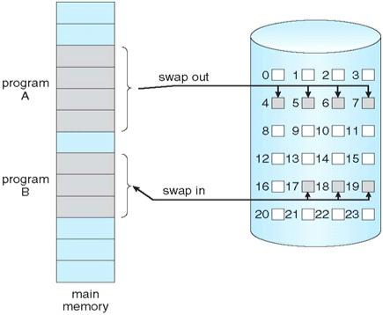
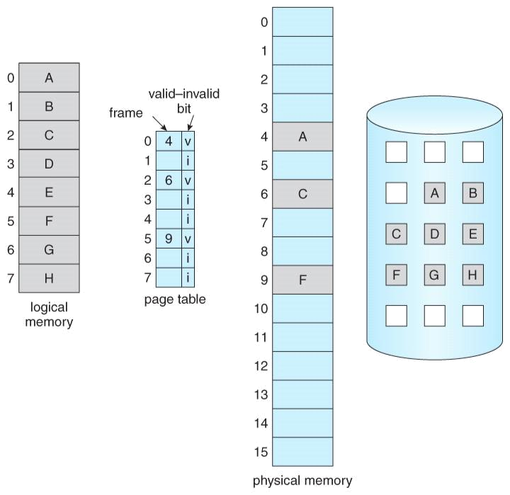

The Page Table Contains two Entries those are used as valid and invalid means whether the Process is Stored into the Page Table. Or Whether the Demand Program is Stored into the Physical Memory So that they can be easily swapped. If the Requested Program is not stored into the Page Table then the Page Table must Contains the Entries as v and I means valid and invalid along the Page Number.

When a user Request for any Operation then the Operating System perform the following instructions:-
- First of all this will fetch all the instructions from the Physical Memory into the Logical Memory.

- Decode all the instructions means this will find out which Operation has to be performed on the instructions.

- Perform Requested Operation.

- Stores the Result into the Logical Memory and if needed the Results will be Stored into the Physical Memory.

Page fault and steps in handling a page fault:

Access to a page marked invalid causes a page-fault trap. The paging hardware, in translating the address through the page table, will notice that the invalid bit is set, causing a trap to the operating system. This trap is the result of the operating system's failure to bring the desired page into memory. The procedure for handling this page fault is straight forward :
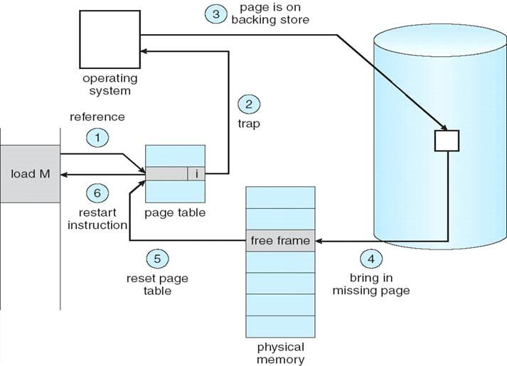

1. We check an internal table (usually kept with the process control block) for this process to determine whether the reference was a valid or an invalid
memory access.

- If the reference was invalid, we terminate the process. If it was valid, but we have not yet brought in that page, we now page it in.

- We find a free frame (by taking one from the free-frame list, for example).

- We schedule a disk operation to read the desired page into the newly allocated frame.

- When the disk read is complete, we modify the internal table kept with the process and the page table to indicate that the page is now in memory.

- We restart the instruction that was interrupted by the trap. The process can now access the page as though it had always been in memory.

In the extreme case, we can start executing a process with no pages in memory.

The hardware to support demand paging is the same as the hardware for paging and swapping:

- Page table. This table has the ability to mark an entry invalid through a valid-invalid bit or special value of protection bits.

- Secondary memory. This memory holds those pages that are not present in main memory. The secondary memory is usually a high-speed disk. It is known as the swap device, and the section of disk used for this purpose is known as swap space.
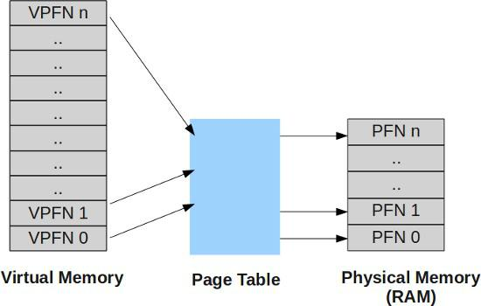

Need for Page replacement
Page replacement algorithms are the techniques using which an Operating System decides
which memory pages to swap out, write to disk when a page of memory needs to be
allocated. Paging happens whenever a page fault occurs and a free page cannot be used
for allocation purpose accounting to reason that pages are not available or the number of
free pages is lower than required pages.

Over-allocation of memory manifests itself as follows. While a user process is executing, a page fault occurs. The operating system determines where the desired page is residing on the disk but then finds that there are no free frames on the free-frame list; all memory is in use.
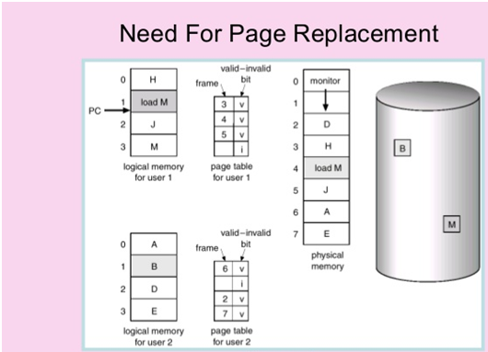

Basic Page Replacement
Page replacement takes the following approach. If no frame is free, we find one that is not currently being used and free it. We can free a frame by writing its contents to swap space and changing the page table (and all other tables) to indicate that the page is no longer in memory . We can now use the freed frame to hold the page for which the process faulted. We modify the page-fault service routine to include page replacement:
1. Find the location of the desired page on the disk.
2. Find a free frame:
a. If there is a free frame, use it.
b. If there is no free frame, use a page-replacement algorithm to select a victim frame
c. Write the victim frame to the disk; change the page and frame tables accordingly.
3. Read the desired page into the newly freed frame; change the page and frame tables.
4. Restart the user process.
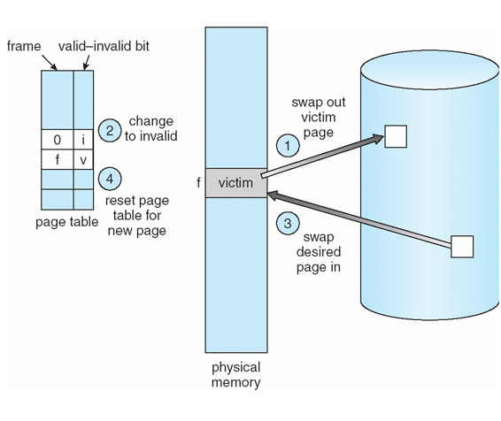
Page replacement is basic to demand paging. It completes the separation between logical memory and physical memory. If we have a user process of twenty pages, we can execute it in ten frames simply by using demand paging and using a replacement algorithm to find a free frame whenever necessary. If a page that has been modified is to be replaced, its contents are copied to the disk. A later reference to that page will cause a page fault. At that time, the page will be brought back into memory, perhaps replacing some other page in the process.

page-replacement algorithms
There are many different page-replacement algorithms. Every operating system probably has its own replacement scheme. How do we select a particular replacement algorithm? In general, we want the one with the lowest page-fault rate. We evaluate an algorithm by running it on a particular string of memory references and computing the number of page faults. The string of memory references is called a reference string. To determine the number of page faults for a particular reference string and page-replacement algorithm, we also need to know the number of page frames available. Obviously, as the number of frames available increases, the number of page faults decreases.
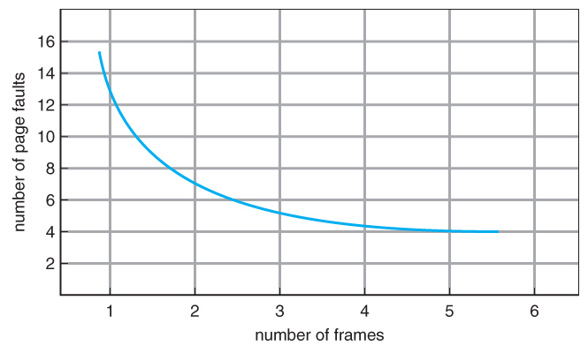

There are three page replacement algorithms:
1) First-in, first-out
2) Optimal page replacement
3) Least recently used

First-in, first-out
- The simplest page-replacement algorithm is a first-in, first-out (FIFO) algorithm. A FIFO replacement algorithm associates with each page the time when that page was brought into memory. When a page must be replaced, the oldest page is chosen.
- We can create a FIFO queue to hold all pages in memory.
- We replace the page at the head of the queue. When a page is brought into memory, we insert it at the tail of the queue.
Example: 7,0,1,2,0,3,0,4,2,3,0,3,2,1,2,0,1,7,0,1
for a memory with three frames.

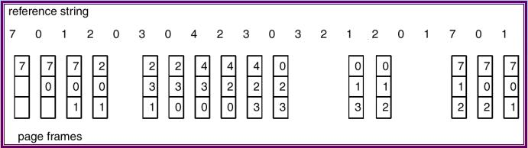
our three frames are initially empty. The first three references (7, 0, 1) cause page faults and are brought into these empty frames. The next reference (2) replaces page 7, because page 7 was brought in first. Since 0 is the next reference and 0 is already in memory, we have no fault for this reference. The first reference to 3 results in replacement of page 0, since it is now first in line. Because of this replacement, the next reference, to 0, will fault. Page 1 is then replaced by page 0. This process continues as shown in Figure . Every time a fault occurs, we show which pages are in our three frames. There are fifteen faults altogether.
We know that if number of frames increases page faults decrease. But here If we increase the number of frames by four then page faults increases .This most unexpected result is known as Belady’s anomaly, for some page replacement algorithms page fault may increase as the number of frames increases.

Optimal page-replacement algorithm
One result of the discovery of Belady’s anomaly was the search for an optimal page-replacement algorithm, which has the lowest page-fault rate of all algorithms and will never suffer from Belady’s anomaly. such an algorithm exist and has been called OPT or MIN. It is simply this
Replace the page that will not be used for the longest period of time.

Use of this page-replacement algorithm guarantees the lowest possible page fault rate for a fixed number of frames.
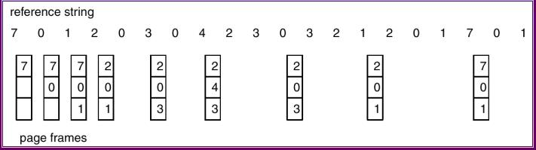

For example, on our sample reference string, the optimal page-replacement algorithm would yield nine page faults. The first three references cause faults that fill the three empty frames. The reference to page 2 replaces page 7, because page 7 will not be used until reference 18, whereas page 0 will be used at 5, and page 1 at 14. The reference to page 3 replaces page 1, as page 1 will be the last of the three pages in memory to be referenced again. With only nine page faults, optimal replacement is much better than a FIFO algorithm, which results in fifteen faults.

The optimal page-replacement algorithm is difficult to implement, because it requires future knowledge of the reference .As a result, the optimal algorithm is used mainly for comparison studies.

Least Recently Used

- When a page must be replaced, LRU chooses the page that has not been used for the longest period of time.
- We can think of this strategy as the optimal page-replacement algorithm looking backward in time, rather than forward.
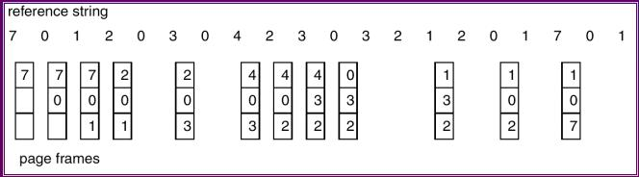

The LRU algorithm produces twelve faults. Notice that the first five faults are the same as those for optimal replacement. When the reference to page 4 occurs, however, LRU replacement sees that, of the three frames in memory, page 2 was used least recently. Thus, the LRU algorithm replaces page 2, not knowing that page 2 is about to be used. When it then faults for page 2, the LRU algorithm replaces page 3, since it is now the least recently used of the three pages in memory
The LRU policy is often used as a page-replacement algorithm and is considered to be good. The major problem is how to implement LRU replacement. An LRU page-replacement algorithm may require substantial hardware assistance. The problem is to determine an order for the frames defined by the time of last use. Two implementations are feasible:

Counter: In the simplest case, we associate with each page-table entry a time-of-use field and add to the CPU a logical clock or counter. The clock is Incremented for every memory reference. Whenever a reference to a page is made, the contents of the clock register are copied to the ti1ne-of-use field in the page-table entry for that page. In this way, we always have the "time" of the last reference to each page. We replace the page with the smallest time value. This scheme requires a search of the page table to find the LRU page and a write to memory (to the time-of-use field in the page table) for each memory access. The times must also be maintained when page tables are changed (due to CPU scheduling). Overflow of the clock must be considered.

Stack:
- when a reference is made, remove page number from stack and push onto stack
- most recently used page is always on top
- least recently used page is always on bottom
- use doubly-linked-list with head and tail pointers to implement
- no search for replacement page number
4 7 0 7 1 0 1 2 1 2 7 1 2
Top of the stack
2
1
0
7
4

LRU belongs to a class of page-replacement algorithms known as stack algorithms which never exhibit Belady's anomaly.
Alloction of frames
Consider a single-user system with 128 KB of memory composed of pages 1 KB in size. This system has 128 frames. The operating system may take 35 KB, leaving 93 frames for the user
process. Under pure demand paging, all 93 frames would initially be put on the free-frame list. When a user process started execution, it would generate a sequence of page faults. The first 93 page faults would all get free frames from the free-frame list. When the free-frame list was exhausted, a page-replacement algorithm would he used to select one of the 93 in-memory pages to be replaced with the 94th, and so on. When the process terminated, the 93 frames would once again be placed on the free-frame list.

- Minimum Number of Frames
- We must also allocate at least a minimum number of frames.
- maintain 3 free frames at all times
- consider a machine where all memory-reference instructions have only 1 memory address → need 2 frames of memory
  - now consider indirect modes of addressing
  - potentially every page in virtual memory could be touched, and the entire virtual memory must be in physical memory
  - place a limit the levels of indirection
- the minimum number of frames per process is defined by the computer architecture
- the maximum number of frames is defined by the amount of available physical memory

- Allocation Algorithms
- m frames, n processes
- equal allocation: give each process m/n frames
- alternative is to recognize that various processes will need different amounts of memory
  - consider
    - 1k frame size
    - 62 free frames
    - student process requiring: 10k
    - interactive database requiring: 127k
it makes no sense to give each process 31 frames
the student process needs no more than 10 so the additional 21 frames are wasted
- proportional allocation:
  - m frames available
  - size of virtual memory for process p_{i} is s_{i}
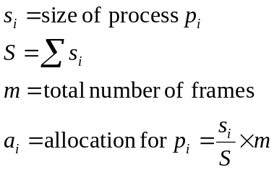
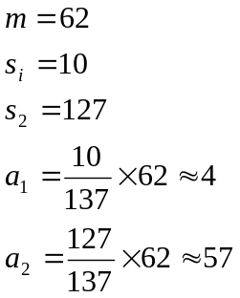
- Global vs. Local Allocation
- is page-replacement global or local?
- global: one process can select a replacement frame from the set of all frames (i.e., one process can take a frame from another or itself) (e.g., high priority processes can take the frames of low priority processes)
- local: each process can only select from its own set of allocated frames
- local page replacement is more predictable; depends on no external factors
- a process which uses global page replacement cannot predict the page fault rate; may execute in 0.5 seconds once and 10.3 on another run
- overall, global replacement results in greater system throughput
Thrashing
- high page activity is called thrashing
- a process is thrashing if it spends more time paging than executing
- scenario:
The process scheduler see that CPU utilization is low.
So we increase the degree of multiprogramming by introducing a new process into the system.
One process now needs more frames.
It starts faulting and takes away frames from other processes. (i.e., global-page replacement).
These processes need those pages and thus they start to fault, taking frames from other processes.
These faulting processes must use the paging device to swap pages in and out.
As they queue up on the paging device, the ready-queue empties.
However, as processes wait on the paging device, CPU utilization decreases.
The process scheduler sees the decreasing CPU utilization and increases the degree of multiprogramming, ad infinitum.
The result is thrashing, page-fault rates increase tremendously, effective memory access time increases, no work is getting done, because all the processes are spending their time paging.

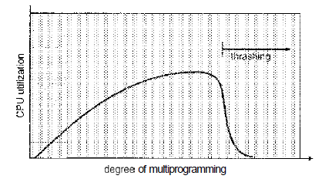

Locality Model
  - as a process executes, it moves from locality to locality
  - a locality is a set of pages used together. A program is generally composed of several localities which may overlap.
  - for instance, when a function is called, it defines a new locality
  - the locality model is the basic unstated assumption behind cache; if accesses to any types of data were random rather than patterned, cache would be useless.
  - if we allocate enough for a process to accommodate its current locality, it will fault for the pages in its locality until all of these pages are in memory. Then it will not fault again until it changes locality.
  - if we allocate fewer frames than the size of the current locality, the process will thrash since it cannot keep in memory all the pages which it is actively uses.

Working Set Model
  - based on the assumption of locality
  - Δ defines the working-set window: some # of memory references
  - examine the most recent Δ page references
  - the set of pages in the most recent Δ is the working set or an approximation of the program's locality.
  - the accuracy of the working set depends on the selection of Δ
  - if Δ is too small, it will not encompass the entire locality
  - if Δ is too large, it may overlap several localities
  - if Δ is ∞, the working set is the set of all pages touched during process execution
  - WSS_{i} is working set size for process p_{i}
  - D = Σ WSS_{i}, where D is the total Demand from frames
  - if D > m, then thrashing will occur, because some processes will not have enough frames
Using the working-set strategy is simple:
  - the OS monitors the working set of each process
  - and allocates to that working set enough frames to provide it with its working-set size
  - if there are enough extra frames, a new process can be initiated
  - if the sum of the working set sizes increases, exceeding the total number of available frames, the OS selects a process to suspend
  - the working set strategy prevents thrashing while keeping the degree of multiprogramming as high as possible and optimizes CPU utilization.
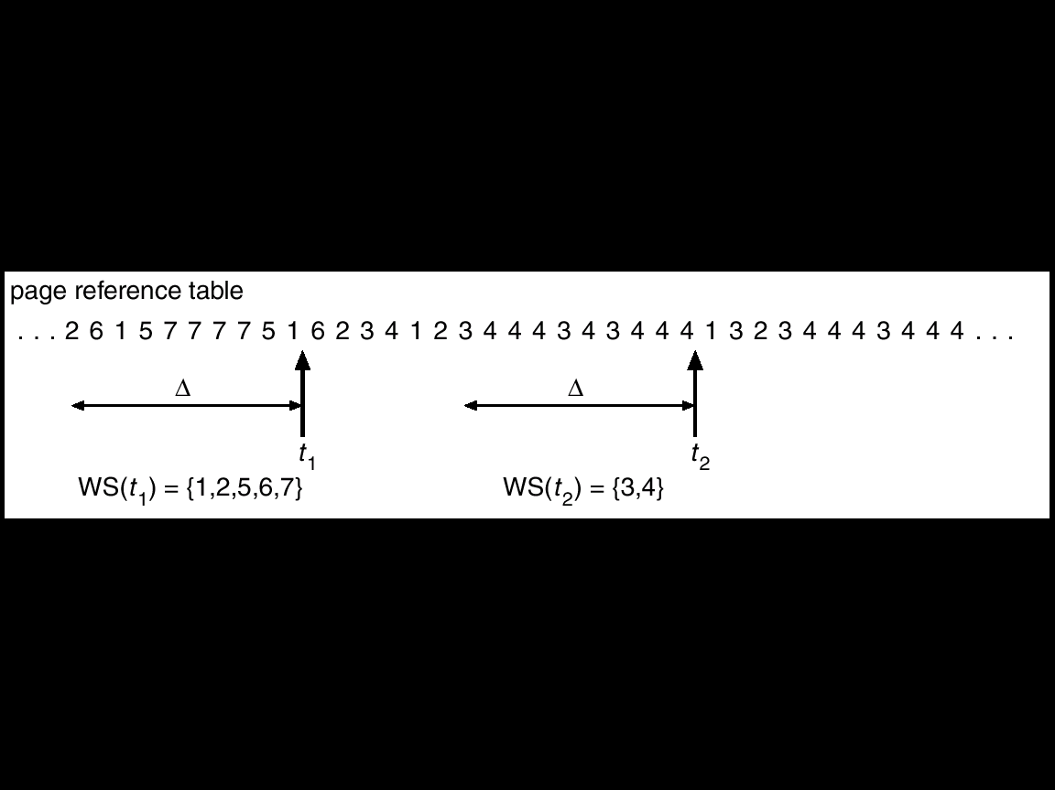

Page Fault Frequency
  - working set model is successful but keeping track of the working set can become complex
  - using page-fault frequency (PFF) is a more direct approach to prevent thrashing
  - if PFF is too high, we know the process needs more frames
  - if PFF is too low, then we know the process has too many frames
